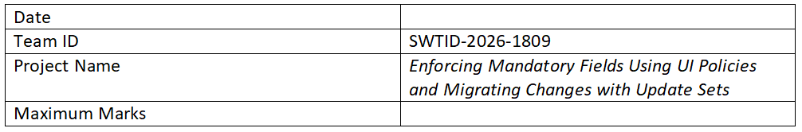

Project Documentation

1. Introduction
Project Title: Enforcing Mandatory Fields Using UI Policies and Migrating Changes with Update Sets
Team Members:
- [Your Name] – Developer
- [Member 2] – Tester
- [Member 3] – Documentation

2. Project Overview
Purpose: The purpose of this project is to ensure data integrity by enforcing mandatory fields using UI Policies and to manage system changes efficiently using Update Sets.
Features:
- Enforcing mandatory fields dynamically using UI Policies
- Real-time form validation
- Conditional field visibility and requirement
- Migration of configurations using Update Sets
- Tracking and managing changes across environments

3. Architecture
Frontend: ServiceNow platform interface with UI Policies.
Backend: Business rules and scripts within ServiceNow.
Database: ServiceNow tables storing structured data.

4. Setup Instructions
Prerequisites:
- ServiceNow instance access
- Admin or developer role
- Basic knowledge of UI Policies and Update Sets
Installation:
1. Log in to ServiceNow
2. Configure UI Policies
3. Create an Update Set
4. Capture changes
5. Move Update Set to target instance

5. Folder Structure
- UI Policies
- Scripts
- Update Sets

6. Running the Application
- Open ServiceNow
- Navigate to module
- Test UI policies
- Verify mandatory fields
- Apply Update Sets

7. API Documentation
- REST APIs (GET, POST)
- Table-based operations

8. Authentication
- ServiceNow login system
- Role-based access control (RBAC)

9. User Interface
- Dynamic mandatory fields
- Conditional visibility
- Improved UX

10. Testing
- Manual testing
- Validate UI Policies
- Test Update Set migration

11. Screenshots or Demo
- UI Policy screenshots
- Form behavior
- Update Set migration

12. Known Issues
- UI Policy conflicts
- Missing Update Set capture
- Permission issues

13. Future Enhancements
- Automation testing
- External integrations
- Advanced validation
- UI improvements

